APPLICATION FORM
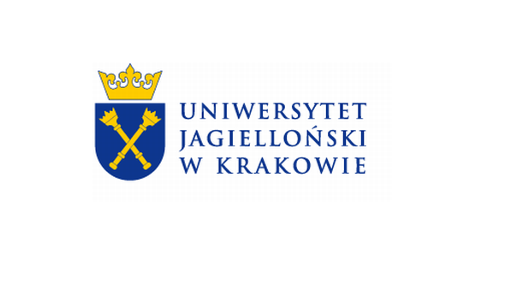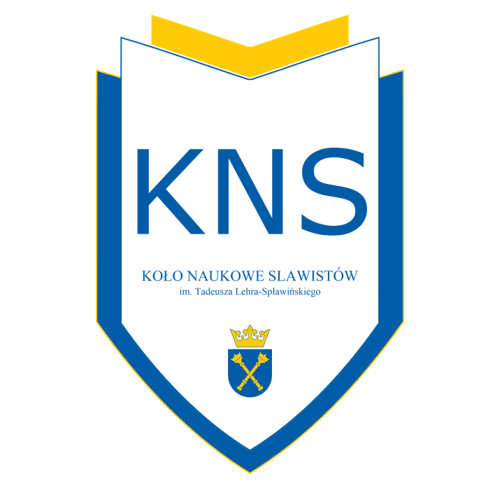
Slavic regions which are difficult to change - stereotypes, beliefs, perception

Scientific conference for students and PhD students
Cracow, 19-20.11.2015

Participant's Details

Name and Surname:
University Name and Institute:
Year and Type of studies (BA, MA or PhD):
Language of the presentation:
E-mail:
Phone number:

Title of the paper in the language of the presentation:

Abstract in the language of the presentation (1000-2000 words):

Introductory Bibliography:

Additional equipment (computer, projector, other?) YES NO

Please send your completed Application Form to the e-mail address below before 22nd June 2015:
konferencja2015kns@gmail.com

In the name of the file containing your Application Form please include your details in the following format: Surname, Name and the abbreviated name of your University (e.g. Kowalski Jan UJ)

